H.T No
Regulations:
A18

Sreenidhi Institute of Science and Technology
(An Autonomous Institution)
Code No: 7B310 Date: 01-Mar-2023 (FN)

B.Tech II-Year I- Semester External Examination, February/March-2023 (Supplementary)
MACHINE DRAWING AND COMPUTER AIDED DRAWING PRACTICE (ME)

Time: 3 Hours Max.Marks:70

Note: a) No additional answer sheets will be provided.
b) All sub-parts of a question must be answered at one place only, otherwise it will not be valued.
c) Missing data can be assumed suitably.
Bloom's Cognitive Levels of Learning (BCLL)

Remember | L1 | Apply | L3 | Evaluate | L5
Understand | L2 | Analyze | L4 | Create | L6

Part - A Max.Marks:30

ANSWER ANY TWO QUESTIONS. EACH QUESTION CARRIES 15 MARKS.

1. | Draw the three views of a hexagonal headed bolt of nominal diameter 25 mm and length 100mm with a hexagonal nut and washer | [15M]
2. | Draw the sectional view from the front, and view from the side of a cotter joint with sleeve used to connect two rods of 50 mm diameter each | [15M]
3. | Draw the sectional view from the front and view from the top, of the following riveted joints, to join plates of thickness 10 mm single riveted, single strap butt joint | [15M]

Part – B Max.Marks:40
Part-B (is Compulsory 40 Marks)

4. |  | Assemble all parts of the following figure, and draw the following views:  (i) Half sectional front view and  (ii) Top view | [40M]

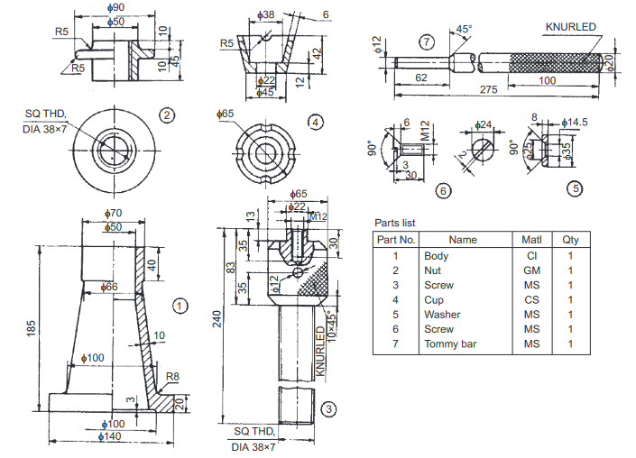

-- 00 -- 00 –

